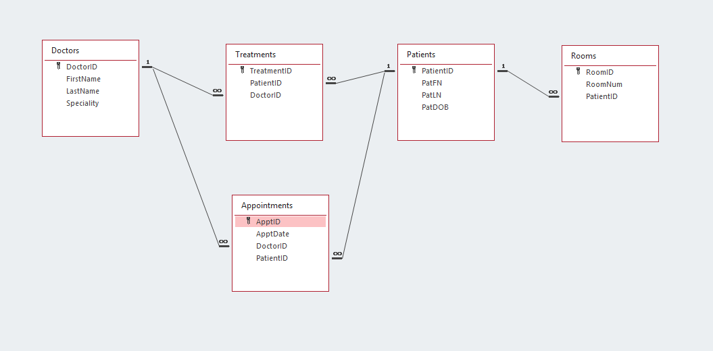

SQL:
Doctors:
CREATE TABLE Doctors
(
DoctorID AUTOINCREMENT,
FirstName VARCHAR (25),
LastName VARCHAR (30),
Speciality VARCHAR (100),
PRIMARY KEY (DoctorID)
)
;

Patients:
CREATE TABLE Patients
(
PatientID AUTOINCREMENT,
PatFN VARCHAR (25),
PatLN VARCHAR (30),
PatDOB DATE,
PRIMARY KEY (PatientID)
)
;

Appointments:
CREATE TABLE Appointments
(
ApptID AUTOINCREMENT,
ApptDate DATE,
DoctorID INT,
PatientID INT,
PRIMARY KEY (ApptID),
FOREIGN KEY (DoctorID) REFERENCES Doctors (DoctorID),
FOREIGN KEY (PatientID) REFERENCES Patients (PatientID)
)
;

Treatments:
CREATE TABLE Treatments
(
TreatmentID AUTOINCREMENT,
PatientID INT,
DoctorID INT,
PRIMARY KEY (TreatmentID),
FOREIGN KEY (DoctorID) REFERENCES Doctors (DoctorID),
FOREIGN KEY (PatientID) REFERENCES Patients (PatientID)
)
;

Rooms:
CREATE TABLE Rooms
(
RoomID AUTOINCREMENT,
RoomNum VARCHAR (10),
PatientID INT,
PRIMARY KEY (RoomID),
FOREIGN KEY (PatientID) REFERENCES Patients (PatientID)
)
;

